Chapter 11, Problem 57.

For the circuit in Fig. 11.76, find the average, reactive, and complex power delivered by the dependent voltage source.

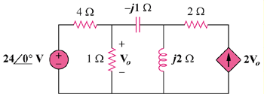

Figure 11.76
For Prob. 11.57.

